참고사이트: <https://www.flo-design.eu/accessible-travel>

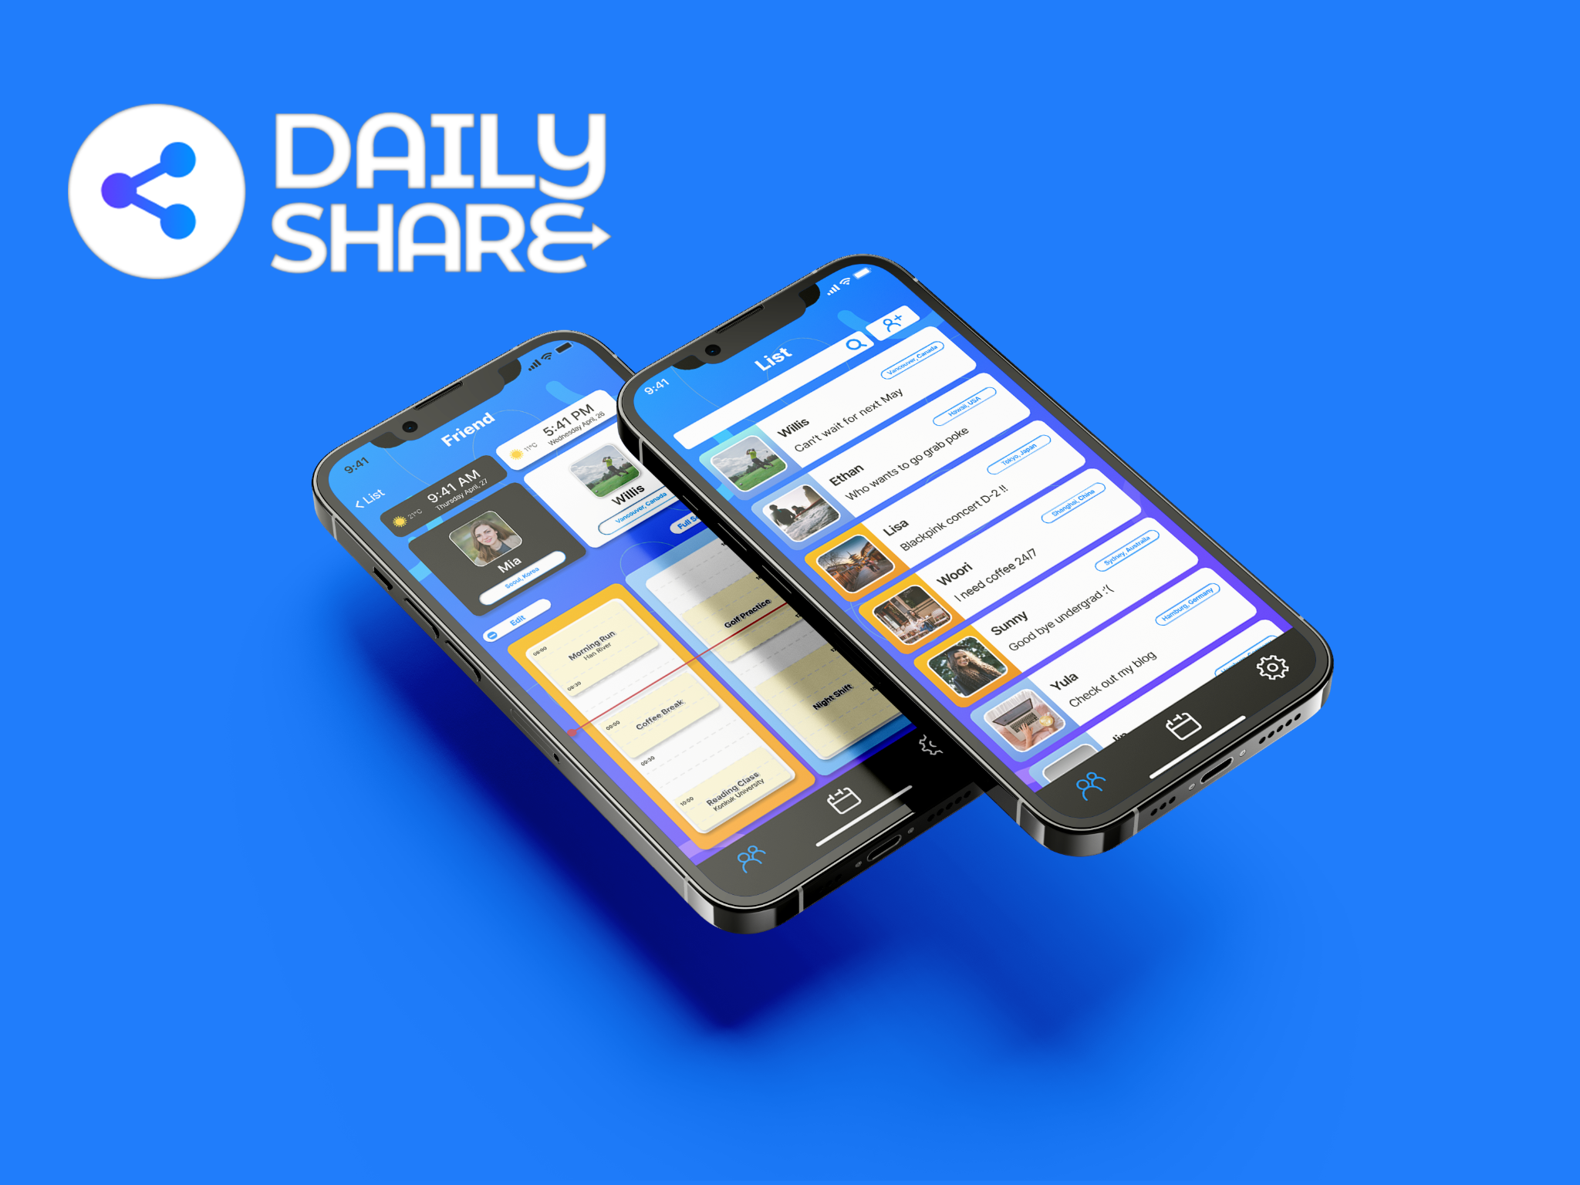

**Project 1: Dailyshare**

부제: Reducing the "Time Zone Difference" Problem

Project Brief: DailyShare is a timetable scheduling application designed to bridge the gap between loved ones living in different time zones. This application seeks to simplify the process of sharing moments and scheduling meetings, making it easier for users to stay connected regardless of the geographical and temporal distances that separate them.

Project Type: University Capstone Project

Timeline: March 2023 - June 2023 (3 months)

Tools: Figma, Marker/Whiteboard

Skills: Competitive Analysis, User Personas, Scenario, Wireframe

Team: 1 UX Designer, 2 Software engineer, 1 Graphic Designer

Role: UX Designer

————————————————————————— 구분선

Contents

**1. User Research (버튼)**

**2. UX Design (버튼)**

**3. Usability Test (버튼)**

**4. Project Prototype (버튼)**

**5. Key Takeaways (버튼)**

————————————————————————— 구분선

**How it all started**

After returning home from an exchange student in Hawaii, I quickly noticed a stark contrast in the depth of my conversations with a friend.

These are the superficial questions that we have been asking.

"How's the weather there?"

"What time is it there?"

"What are you planning to do today?"

These repetitive inquiries were rather a vivid reminder of the vast distance between us - physically and emotionally. Motivated to bridge this gap, I proposed the development of our application as a project in my Human-Computer Interaction (HCI) course.

————————————————————————— 구분선

**1. User Research (버튼)**

**Research Goals**: We want to investigate how people relate to calendar/scheduling platforms. Also, figure out the problems users in long-distance relationships people are struggling with.

**Methodologies:**

1) Competitive Analysis

2) User Interview

#### **Competitive Analysis**

|  | Every time Calendar | Google Calendar | Apple Calendar |
| --- | --- | --- | --- |
| Picture |  |  |  |
| Target market | University Students in South Korea | Users with Google accounts around the world | Apple users around the world |
| Strengths | - Import university courses automatically.  - Choices of color palette as theme | - Excellent integration within Google services like Gmail and Google Meet.  - Suggest the name of the event based on the description.  - Seamless process from making events, adding stakeholders, and sending emails. | - Great integration within the Apple ecosystem such as the Apple Watch and iPhones.  - Automatically creates an event with natural language input. |
| Weakness | - Limited customization | - Concerns of privacy | - Only available on Apple devices |
| Features | —--------------- | —--------------- | —--------------- |
| Signup/Login | v | v | v |
| Separate calendar | x | v | v |
| Monthly View | x | v | v |
| Invitations | v | v | v |
| Time Zone | x | v | x |
| To-do list | x | v | x |
| Add location | v | v | v |

1. **User Interview**

5 people were interviewed. All interviews have been conducted remotely by using Google Meet.

- 2 Individuals in Long-Distance Relationships

- 2 Individuals with Experience Studying Abroad

- 1 Individual with a Friend Residing Abroad

**Affinity Mapping:**

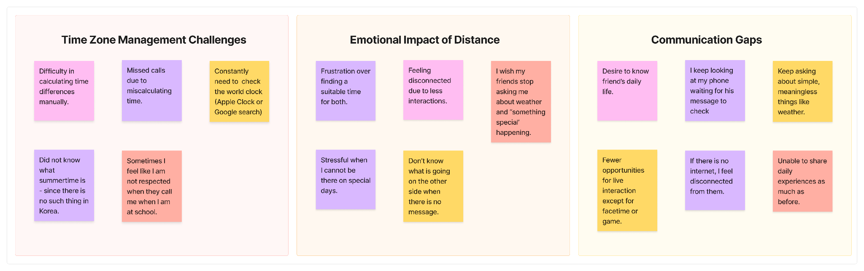

#### **Research Findings**

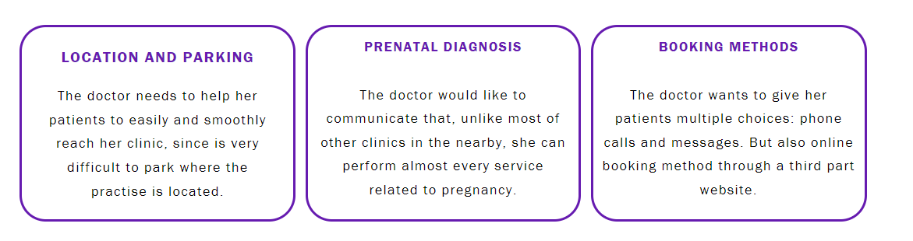

**!메모 디자인 - 이렇게 여러개 가로 배열**

1. Complexity of Time Zone Management

Users struggle with manually managing time differences, leading to missed communications and frustration.

2. Craving for Deeper Connection

There's a significant desire for more meaningful interactions beyond superficial conversations, highlighting a gap in current communication methods.

3. Sensitivity to Time Differences

A lack of awareness or consideration for time zone differences often disrupts daily routines and causes feelings of neglect.

4. Reliance on Digital Tools

The dependency on technology for connection introduces challenges, especially when faced with internet outages, underscoring the need for more robust communication platforms.

**Personas (메모: 특정 사람 사진 필요)**

**User Persona #1**



ㄴ 파일명 : yula.jpg

Name: Yula Lee

23 Y/O - UNIVERSITY STUDENT IN KOREA

Personality : Curious, Friendly

Hobbies : Social media, Reading, Music

Quote: "Korea is now 1 pm… so it's 9 am in Vancouver. He must be working by now."

Bio: Yula currently resides in South Korea and is navigating a long-distance relationship with her boyfriend in Canada. The relationship spans two years, during which time zone differences have consistently posed challenges. Yula finds it difficult to mentally calculate the time difference and align her schedule with her boyfriend's, especially considering his part-time job from 5 pm to 7 pm Canada time. This challenge impedes her ability to feel connected and informed about his daily life.

Goal:

- To effortlessly understand and keep track of her boyfriend’s schedule and daily activities.

- To feel closer by having a real-time sense of what her boyfriend is doing.

Frustration:

- The mental strain and confusion caused by frequent calculations to figure out the time difference.

- The difficulty of coordinating schedules that align with both their time zones, leading to less communication and shared experiences.

**User Persona #2**

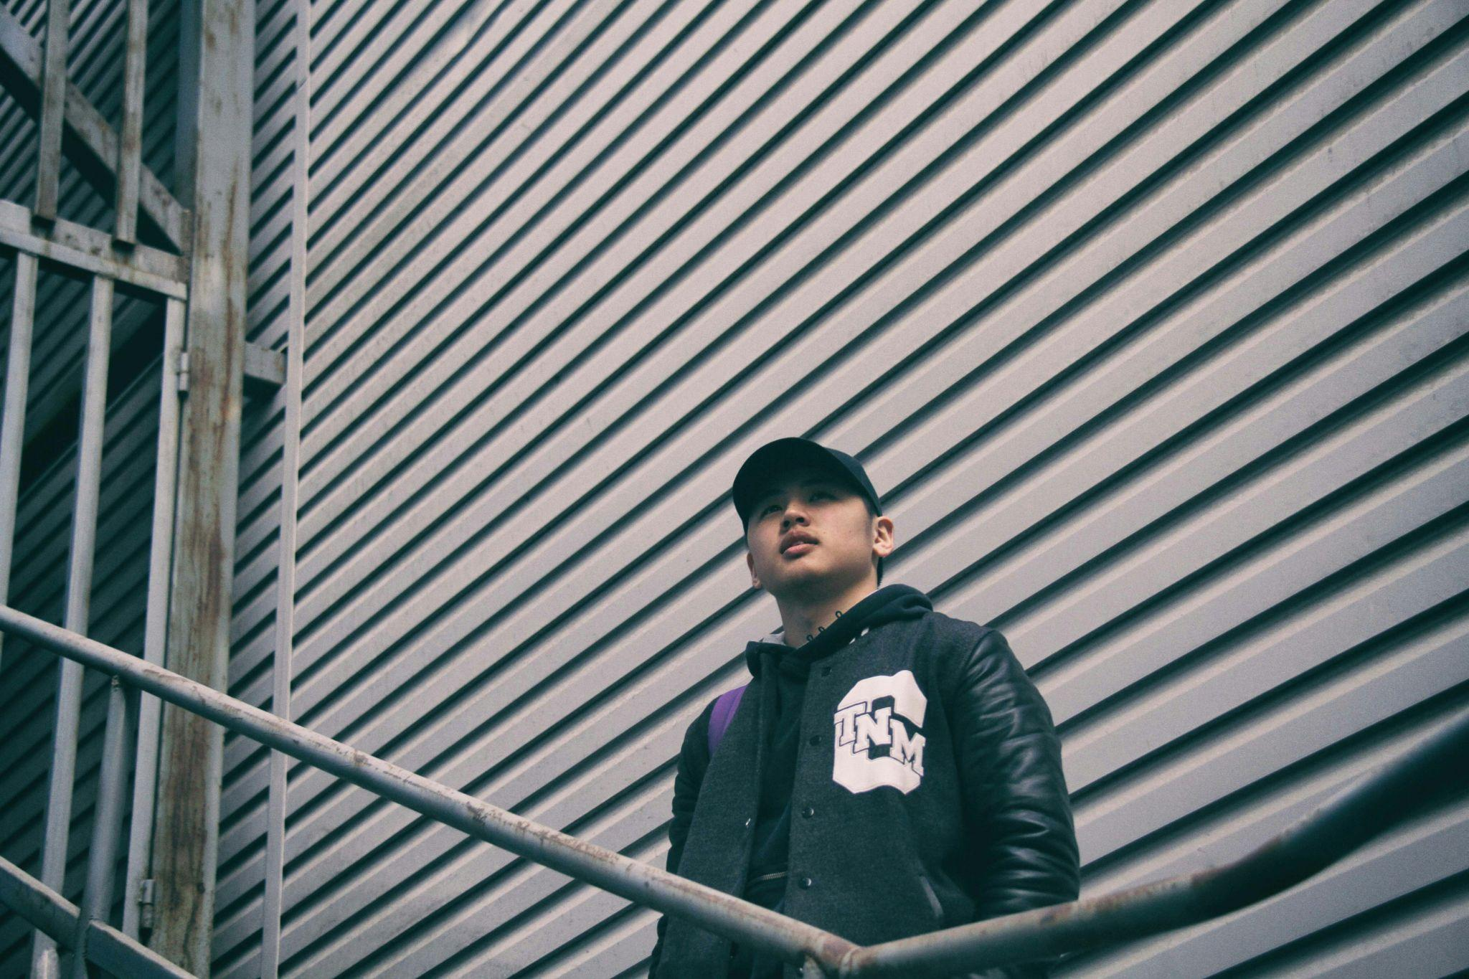

ㄴ 파일명: brian.jpg

Name: Brian Jang

22 Y/O - INTERNATIONAL STUDENT STUDYING ABROAD

Personality: Curious, Affectionate

Hobbies: Basketball, Gaming

Quote: “My friends keep asking me what I'm doing and what the weather is like. Korean university students use the Everytime Calendar a lot. How can I share my daily life?.”

Bio:

Brian has a wide circle of friends and is currently pursuing his studies in New York. He frequently receives questions from friends and family back home about his local time, the weather, his daily schedule, and local events. Initially, Brian patiently responded to each query individually, but over time, these repetitive questions became tiresome.

Goal:

- To seamlessly share his daily schedule, local weather, and updates with friends and family to reduce repetitive inquiries.

- To integrate his life abroad with his social circle back home without the constant need for manual updates.

Frustration:

- The frequency of answering the same questions about his time zone, weather, and daily activities.

- Finding an efficient way to share his life abroad with his friends and family that doesn’t require constant repetition.

————————————————————————— 구분선

**2. UX Design (버튼)**

**Requirements Matrix**

Based on insights from two distinct user personas identified during our user research, I have developed a requirements matrix to move on to the UX design phase.

| **Priority** | **Persona** | **Description** | **Data Needs** | **Functional Needs** | **Product Quality** | **Constraints** |
| --- | --- | --- | --- | --- | --- | --- |
| 1st | Yula Lee | Interested in accessing her friend's information and local time | 1) Friend's information (status message, profile picture, schedule)  2) Local information (local time) | Ability to view and search for friend's profile details and local information directly from the friend list | High readability and intuitive navigation for accessing schedules and local times | Ensuring privacy and data security |
| 2nd | Brian Jang | Wants to easily share his local information and schedule with friends | 1) Personal local information ( weather, local time, local issues)  2) Friend's information (status message, profile picture, schedule) for mutual sharing  3) Friend list | - Setting up personal information (location, weather, issue, time)  - Managing own schedule | - Simplified process for updating personal information and schedules  - Clear user interface for managing friend list and privacy settings | Clear guidelines and criteria for selecting and displaying relevant local issues |

**Product Roadmap**

After having established the requirement matrix, I listed the different features I wanted to include in the website and then prioritized them into a spreadsheet. All the decisions have been supported by user interviews and comparative analysis.

|  | Feature Name | Description | Supporting Research |
| --- | --- | --- | --- |
| P1: Must Have | Time Zone Support | Automatically adjusts and displays times in the user's and their friends' local time zones to simplify scheduling across different regions. | User Interviews, Comparative Analysis |
|  | Schedule Managing | Allows users to create, edit, and manage their schedules. | Comparative Analysis |
|  | Schedule Sharing | Enables users to share their schedules with friends. | User Interviews, Comparative Analysis |
|  | Local Issues | Provides information on local issues in the user's and friends' location, facilitating shared experiences. | User Interviews |
|  | Signup/Login | Easy and secure signup/login process to access the app's features. | Comparative Analysis |
|  | Friend List | Manage a list of friends within the app, with options to add and remove. | User Interviews, Comparative Analysis |
|  | Location Setting | Allows users to set and share their current location to automatically update local time and weather information. | User Interviews |
| P2: Nice to Have | Status Message | Enables users to post status messages that friends can see, sharing moods, activities, or thoughts. | User Interviews |
|  | Profile Picture | Allows users to update their profile picture, helping friends easily identify and feel closer to each other. | User Interviews |
| P3: Surprising and Delightful | Seamless Integration with Other Services | Integrates with other social media and email to streamline communication and scheduling. | Comparative Analysis |
|  | Location Notification | Sends notifications to friends when the user arrives at or leaves a significant location. | User Interviews |
| P4: Can come later | Language Translation | Provides real-time language translation for messages and posts, bridging the communication gap between international friends. | User Interviews, Comparative Analysis |
|  | Augmented Reality (AR) Meetups | Uses AR technology to create virtual meetups in significant places, offering a new way to experience shared moments. | User Interviews, Comparative Analysis |

#### **Information Architecture**

Guided by the product roadmap, we have decided to start designing from P1: Must Have to P2: Nice to Have. To communicate with developers, we made two different types of IA which are scenario and data structure,

1) Information Architecture - Scenario

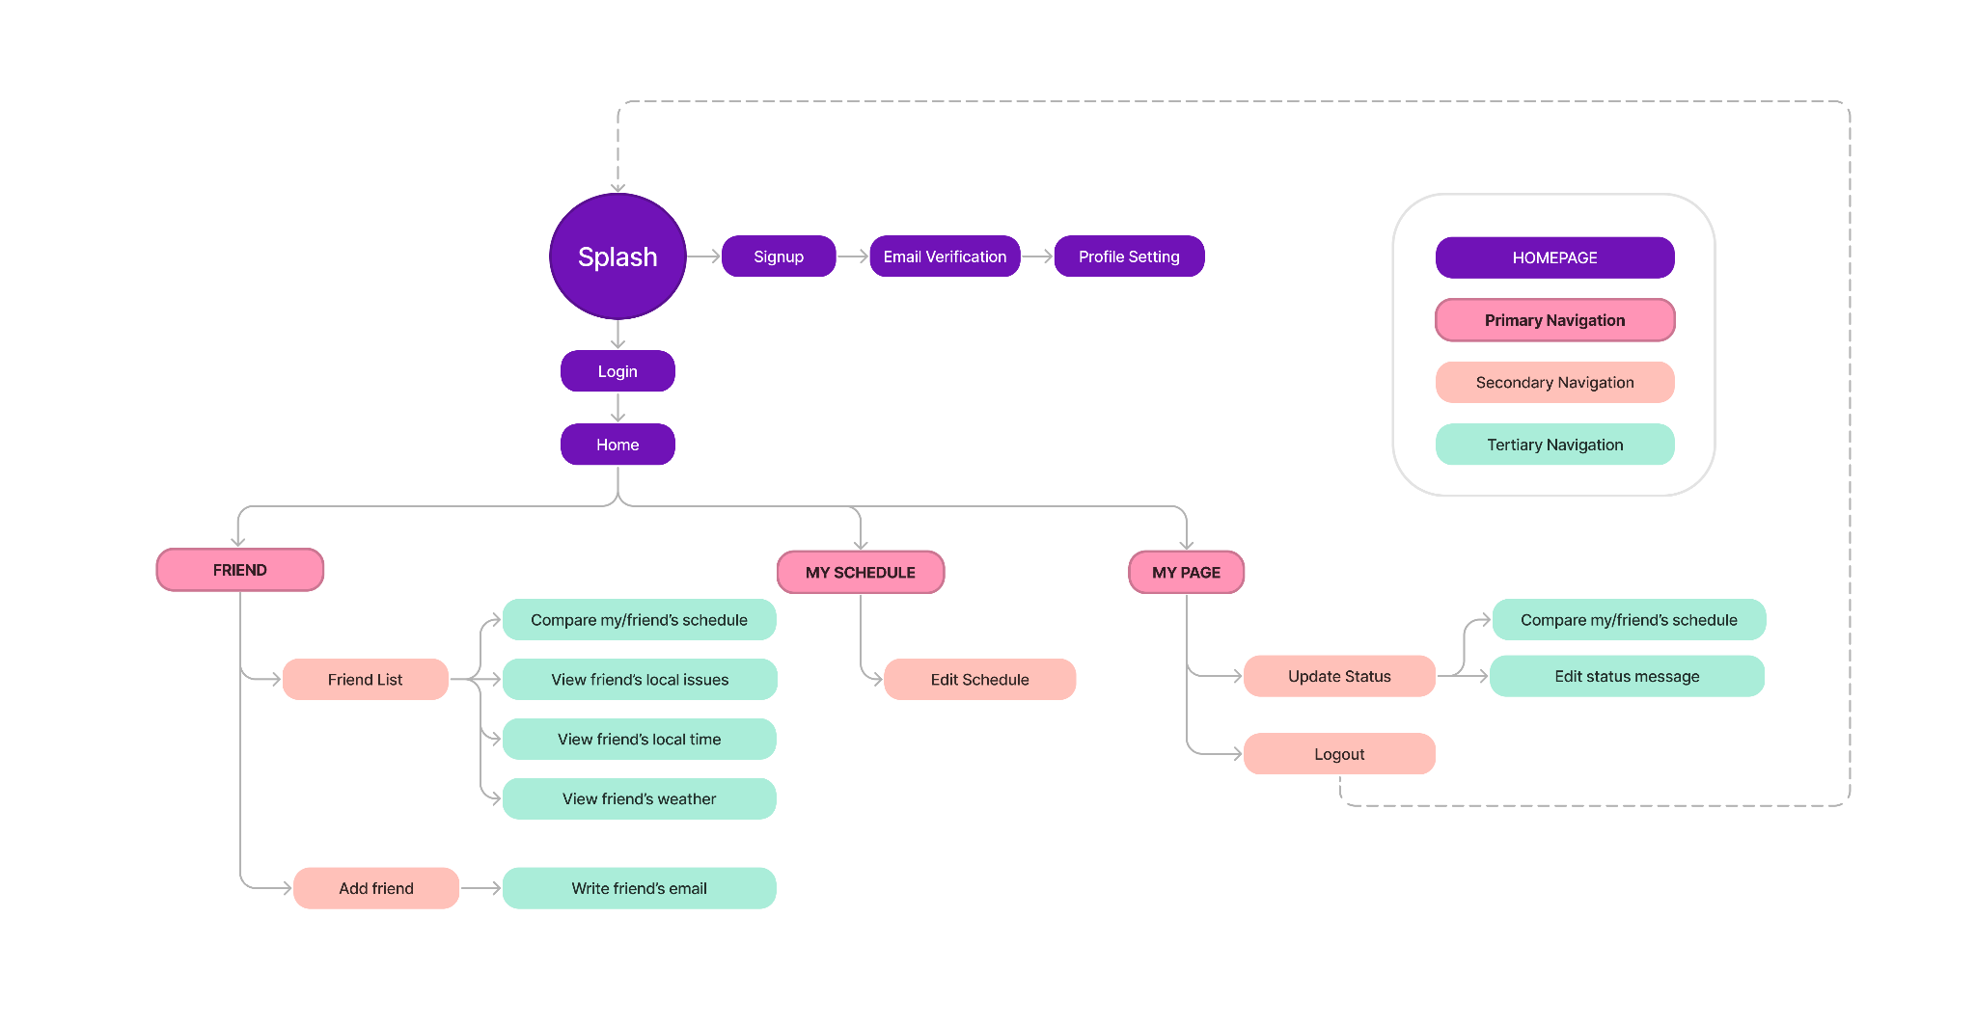

2) Information Architecture - Data

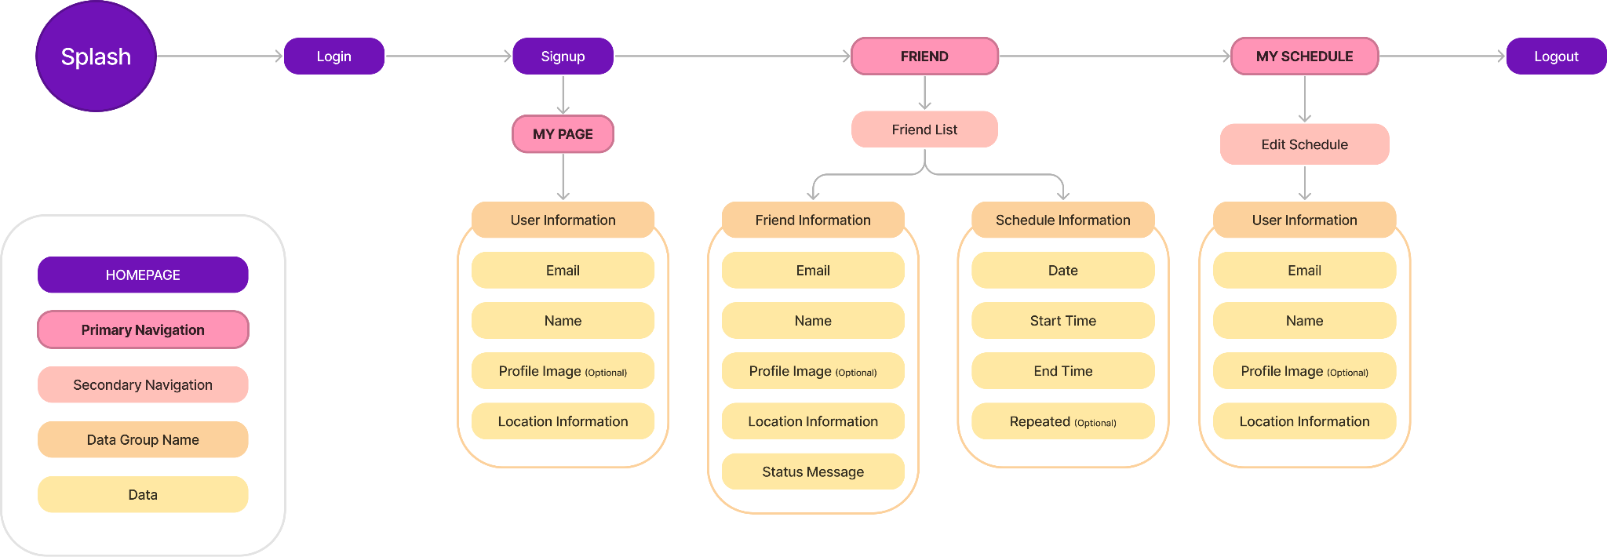

#### 

#### **User Flows**

#### It was clear from the Information Architecture that I needed to design 2 main User Flows.

#1 Setting Up an Account and Profile

Splash Screen: The user opens the application.

Sign Up: The user selects the sign-up button.

Email Verification: The user enters their email and verifies it.

Profile Setting: The user completes their profile setup including name and location.

Home: The user navigates to the home screen, where they have access to primary, secondary, and tertiary navigation options.

#2 Managing and Sharing Schedules

Home Screen: The user logs into the app and starts on the home screen.

My Schedule: The user navigates to their schedule management section.

Edit Schedule: User adds or edits events in their schedule.

Friend List: The user goes to their friend list from the home screen.

Compare Schedules: The user selects a friend and compares their friend's schedule with their own.

Share Schedule: The user shares their schedule with a friend or a group of friends.

**Task Flow**

#1: Adding a Friend

Home Screen: The user is on the home screen after logging in.

Friend List: The user navigates to their friend list.

Add Friend: The user selects the option to add a friend.

Enter Details: The user enters the friend's email to send an invitation.

Invite Sent: The system sends an invitation, and the user waits for the friend to accept.

#2: Updating Status Message

My Page: The user navigates to 'My Page' from the home screen.

Update Status: The user selects the option to update their status.

Edit Status Message: The user edits their status message.

Save Changes: The user saves the updated status message.

Confirmation: The system confirms the status update, and it becomes visible to friends.

#### 

#### **Wireframes**

Initially, we sketched out the design on a whiteboard using markers. Thanks to the engineers' insights, we were able to thoughtfully consider how deeply users would interact with the features for an effective experience. Following that, I created the wireframe designs using Figma.

Whiteboard design with engineers

(이미지 4개, 파일에 따로 저장되어있음 - **파일명: proj1_wireframes4**)

Figma design

(이미지 10개, 파일에 따로 저장되어있음 - **파일명: proj1_wireframes10**)

————————————————————————— 구분선

### **3. Usability Test**

Prototype

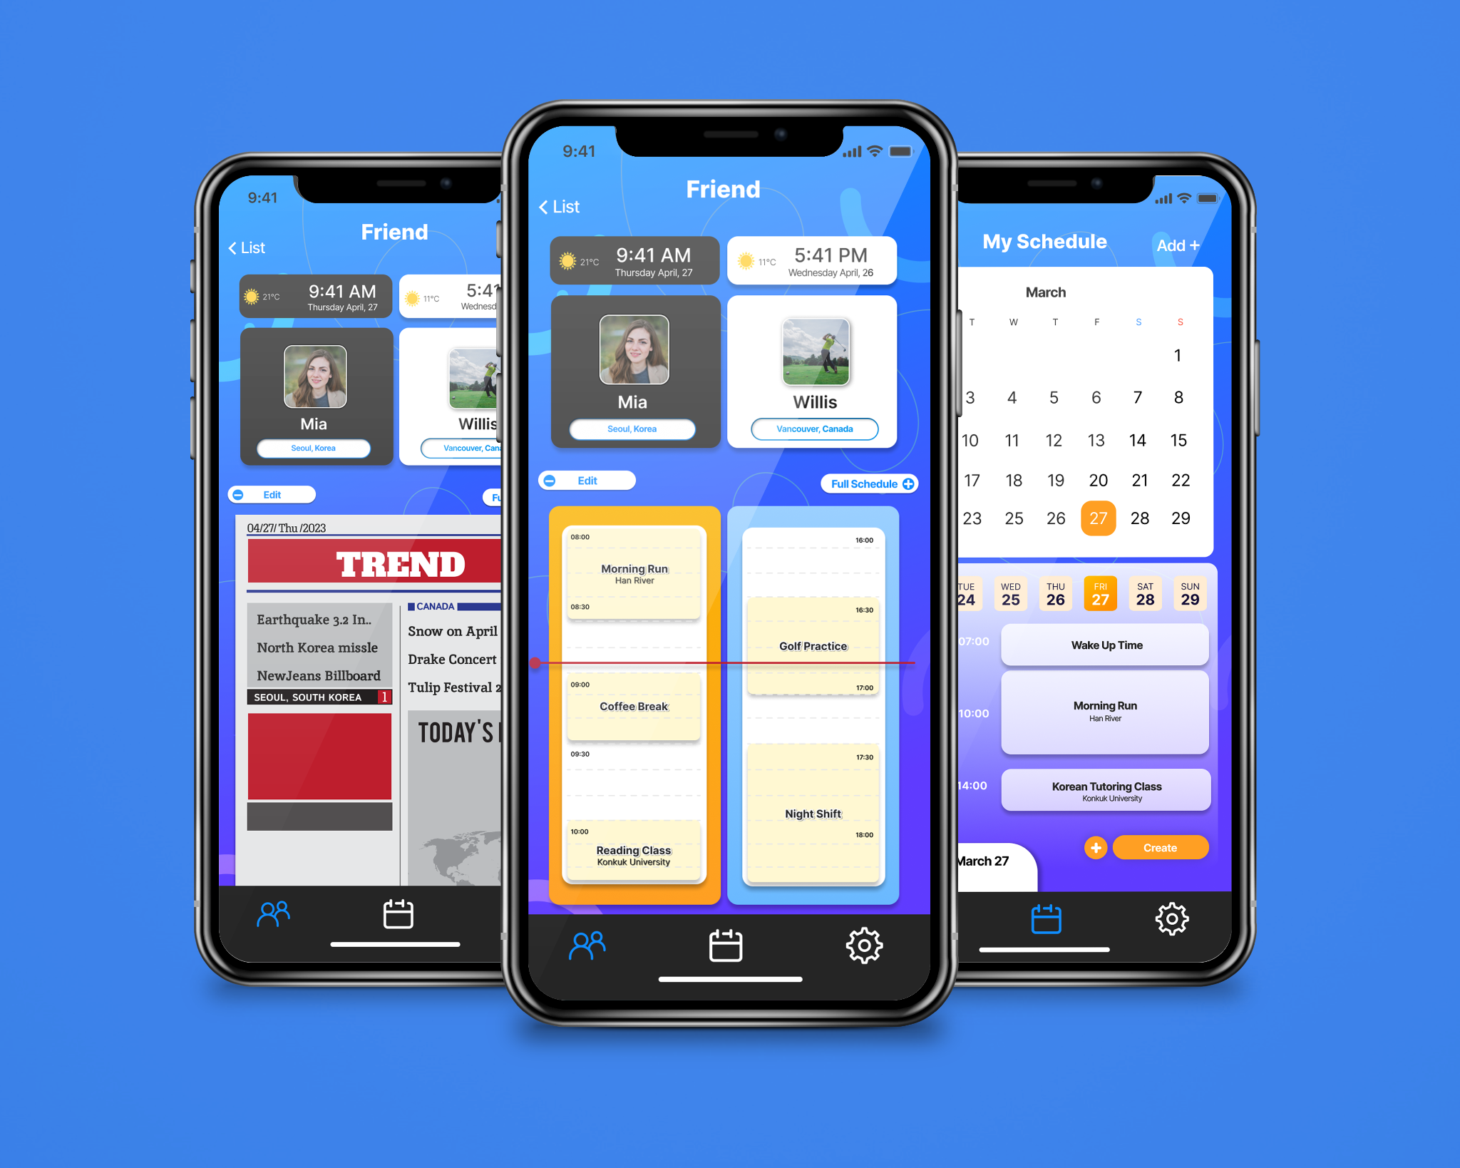

1) Dual-Time Zone Schedule Comparator

The user selects a friend from their list, activating a split-view interface. The left side of the interface displays the user’s profile, which includes their current schedule and local time. The right side simultaneously displays the selected friend’s profile with their schedule adjusted to the user’s local time zone.

2) Intuitive Design of Time

The interface employs a color-coding system to differentiate between AM and PM times, with AM represented by a vibrant orange and PM by a serene blue. This color-coding extends throughout the UI for consistency and ease of understanding, featuring not only on the schedule detail pages but also on the friends list. The friends list provides an at-a-glance view of each friend’s local time with the corresponding AM/PM color cues, thereby improving the organization and quick comprehension of global time zones.

**Outcome**

The prototype I’ve created has been tested on 4 participants. The age range of them was 21 to 30 y/o.

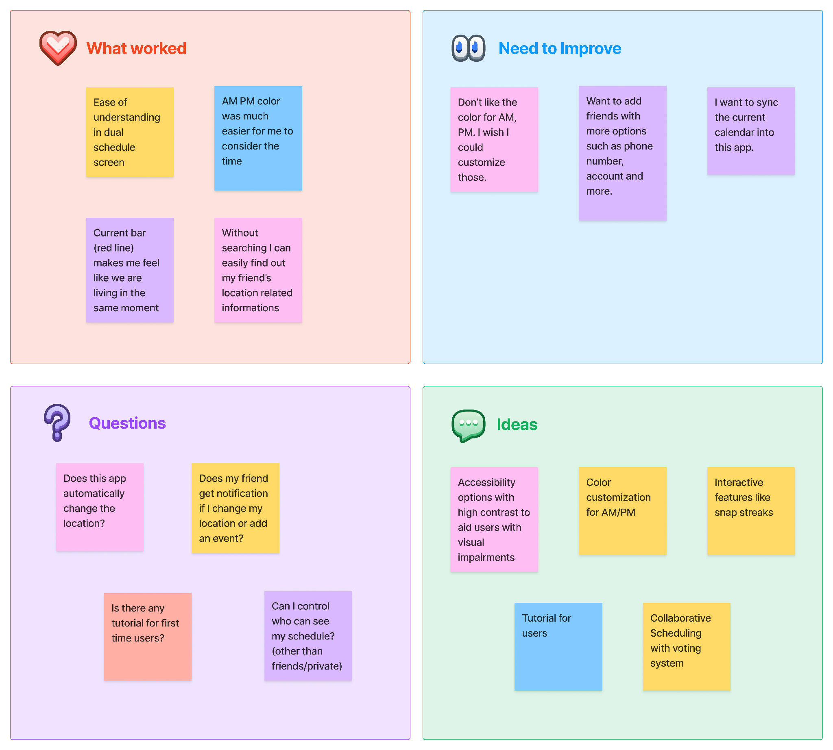

**Iterations**



**! 메모 디자인 - 이렇게 여러개 가로 배열**

To improve location setting:

1) Automatic Location Detection: Implement a feature that automatically detects and sets the user’s location to streamline the setup process and improve accuracy for local time and weather updates.

2) User Control and Confirmation: While automating the location setting, ensure users have the option to confirm or manually override the location to maintain control over their privacy and personal data.

————————————————————————— 구분선

**4. Project Prototype**



<https://www.figma.com/proto/VEuQf1mWBRSA1WDnLxtACr/Dailyshare_prototype_Miajang?page-id=0%3A1&type=design&node-id=0-1&viewport=68%2C437%2C0.17&t=r3r0uTsJpBut5pvv-1&scaling=scale-down&starting-point-node-id=1%3A225&mode=design>

————————————————————————— 구분선

**Key Takeaways (버튼)**

Challenge

As this project was an academic exercise for an ***HCI course*** at university, there are constraints on the ability to fully develop the app and publish it on app stores.

Lesson learned

Through the application of HCI principles, such as ***persona creation and user testing***, the project reinforced the ***importance of centering the design process around the users' needs***.

A key learning was the significance of pinpointing and eliminating user pain points to enhance the overall user experience. This ***"problem-removal" approach*** is crucial for creating intuitive and efficient interactions between users and technology.